Application for the Jazzfruit 2016 competition.

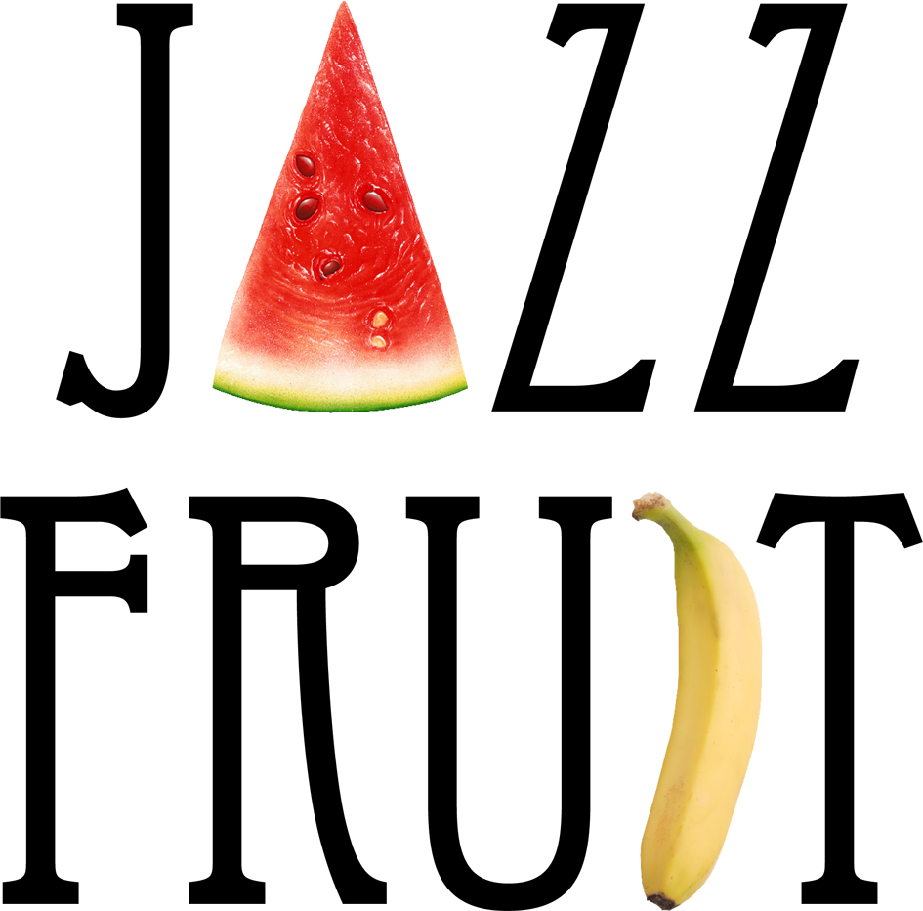

Introduction:

Jazzfruit is a two-round competition for young jazz bands under the auspices of the “Mladi Ladi Jazz” (“Youth Tune the Jazz” - henceforth MLJ) festival. Everyone who follows the basic rules of the competition (see below) can enter the first round. All that is required is that prospective competitors fill in and submit their application form, recordings and three band photos.

The closing date for applications for the 2016 competition is Tuesday 15. 03. 2016.

In the second round, three finalists selected by the organisers of the MLJ festival shall compete for first place on the final night of the competition at Prague's Jazz Dock, which will feature a performance by the American composer and multi-instrumentalist Oran Etkin. The winner will be selected on the basis of votes cast by a jury of specialists and the audience.

The date of the final evening is Wednesday 13. 04. 2016.

Prizes for the winner:

- Use of a recording studio at Studio Hostivar Prague, at a value of 30,000 CZK
(http://www.studiohostivar.cz/)

- A joint concert with SCHMIEDS PLUS (Jazz Dock, Prague 28. 04. 2016)

- Long-term media support for future band activity (CD launch) by the organisers of the MLJ festival.

Competition Rules:

1) Bands can enter the competition if they fulfill all three of the following conditions:
a) at least ¾ of the members have not yet reached the age of 30.
b) the group has not had a commercially distributed album (a contract with a distributor or promotional agency).
c) Has not received a prize or been a finalist of last year's competition.

- Bands will only be accepted to compete if they apply with the application form appended below, with three photographs in print quality and sound recordings by the 15. 03. 2016. In the case of the band not having any sound recordings, they can invite the organisers to attend a performance in Prague or the close vicinity. This performance must take place by the closing date of applications (the organisers however are not obliged to attend the performance). Bands which do not supply sound recordings by the closing date for applications or do not make arrangements with the organisers for other possibilities of hearing them, will be automatically disqualified from the competition.

- On the basis of the submitted sound recordings, the festival organisers shall announce three finalists in the second week of April. Competitors are in their own interest advised to keep Wednesday 13. 04. 2016 free in their diaries in the event of their being invited to participate in the final of the competition in Prague's Jazz Dock, at which the finalists shall be presented to the public and to the panel of professional judges.

- The winners are required to keep the 28. 04. 2016 free in their diaries, when they will be officially announced as the winners of the competition, and when they will perform under the auspices of the MLJ festival on the same night as SCHMIEDS PLUS. Personal attendance at the official announcement is a condition for gaining a right to the winners' prizes.

- The festival organisers hereby relinquish any perceived obligation to financially compensate the winners or the finalists for any expenses incurred in competition-related travel or accommodation.


Application submissions, Queries, Comments to:

Duyen Monika Nguyenová
monika@mladiladijazz.cz
+420 607 112 166

Further information:

www.mladiladijazz.cz

Application Form

Band Name:

Contact Person, telephone, email, website (Myspace etc.)

Band members (name, surname, date of birth, instruments played):

A short resume of the band, max 1800 characters. (accolades, prizes received, musical education of the band members, prominent performances, residencies, any other interesting/useful information.

We submit this application form with the affirmation that to our knowledge all information filled into the form is correct. This application is binding and on the basis of its submission the contact person is obliged to follow the rules of the competition.

A mandatory part of the application are a) submission of sound recordings b) three band photos in print quality c) Technical rider & stageplot d) playlist with authors of 5 tracks. Please attach these to your email, as your application will not be considered complete without them.

